CREATING A LINUX VM AND SSH WITH PUTTY

**Lab Details**

1. In this lab you will learn how to create an Azure Virtual machine using Ubuntu Server 20.04 LTS - Gen 2 image, connect to the virtual machine using SSH.

**Introduction**

**What is an Azure virtual machine?**

* Azure Virtual Machine is a scalable and flexible computing solution provided by Microsoft Azure.
* It allows users to create and manage virtual machines in the cloud with customizable hardware configurations, operating systems, and networking options.
* Users can choose from a wide range of pre-configured virtual machine images or create custom images based on their specific needs.
* Azure virtual machines offer high availability and reliability, with automatic backup and disaster recovery options.
* It is a cost-effective solution, with users only paying for the resources they use and the ability to scale up or down as needed.

**Architecture Diagram**

**Task Details**

1. Sign to Azure Portal
2. Create an Azure Linux Virtual Machine
3. SSH into the virtual machine
4. Delete the Resources

# **Lab Steps**

## **Task 1: Sign in to Azure Portal**

1. Go to the Azure portal by using URL [https://portal.azure.com](https://portal.azure.com/).
2. If it automatically logs into any other azure account, please logout of it and clear cache.
3. Sign in with your given username and password on Azure portal.

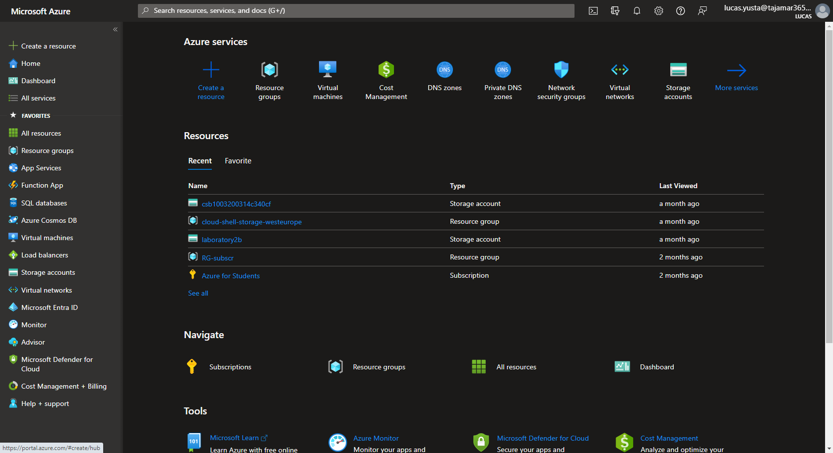

## **Task 2: Create Virtual Machine**

In this task, we will create **Linux Virtual Machine** on Azure Portal.

1. Search for **virtual machines** in the search bar present in the Azure portal.

1. Click on Virtual Machine Blade and then Click on Create Button.
2. In the Basic tab, fill the following details

* Resource group: create  **RG1**
* Virtual machine name: Enter WhizlabsVM
* Region: select **East-US**
* Image: select **Ubuntu Server 20.04 LTS - Gen 2**

* Size: Click on ***See all sizes*** and pick **Standard_B2s**. On selecting the size, click on **Select** button.

* Authentication type: select **SSH Public Key** based
  + Username: Enter **whizlabsuser**
  + SSH public key source: Select **Generate new key pair**
  + Key pair name: Leave the default value
  + Inbound port rules: Leave the default values

1. In the Disks Tab

* OS Disk Type: Select **Standard SSD**

1. In the **Networking** and **Management** tab leave everything as Default and go to **Monitoring** tab.

* Boot diagnostics: select **disable**

1. Click on the **Review + Create** and then click on **Create** button.  
   **NOTE:** In the **Review+Create** Tab if it asks for any preferred email address and phone number, give some random email and phone number.
2. Click on **Download Private Key and create resource**.

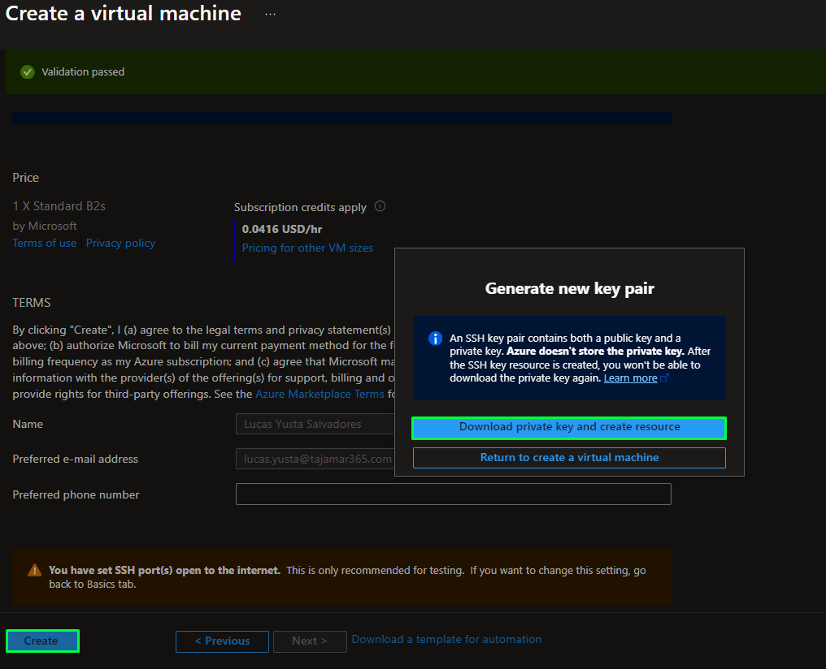

1. Wait Until the Deployment is Completed and click on **Go to Resource** Button.

### **Do You Know?**

Azure virtual machines offer specialized sizes optimized for various workloads, providing unparalleled flexibility and performance tailored to specific application requirements.

## **Task 3: SSH into the virtual machine**

In this task, we will connect **Linux Virtual Machine** using **SSH**.

1. Click on the **Connect** button, and select **SSH**.

1. For Windows Users You have to install putty and putty gen from the links given below

* [PuTTYgen Download](https://www.puttygen.com/download.php?val=4)
* [putty](https://www.chiark.greenend.org.uk/~sgtatham/putty/latest.html)

1. In PUTTYgen Application

* Click onthe **Conversions** tab -> **Import key**, upload the file that you have downloaded while creating the virtual machine
* Click on the **Save Private Key** button

* Save the file with same name as of Public key downloaded from Azure.

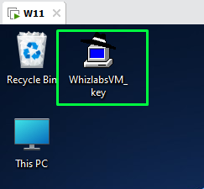

* Close the PUTTYgen application

1. In PUTTY Application

* Give the **public IP address** of the **virtual machine** that we have created

* Go to **SSH** tab and then got to **Auth** tab and then go to **Credentials** tab and load the private key file

* Click on **Open**
* You will be prompted with a security alert , click on **Accept**

* Enter the **username** that you have specified while creating the virtual machine(whizlabsuser)
* You will now be successfully logged into ubuntu virtual machine

1. For mac and Linux users follow the steps given in the official Microsoft documentation

* [Create and use an SSH key pair for Linux VMs in Azure - Azure Virtual Machines | Microsoft Docs](https://docs.microsoft.com/en-us/azure/virtual-machines/linux/mac-create-ssh-keys)

## **Task 4: Delete the Resources**

In this task, we will delete all the resources.

1. In the search box at the top of the Azure portal, enter **Resource groups**. Select **Resource groups** from the search results.
2. Click on the name of the **Resource groups**.
3. Select all the Resources in that **Resource groups.**
4. Go to three dots to the right and then click **Delete** button.

1. Now type **delete** in the box present at the bottom.
2. Click on **Delete** to confirm deletion of resources.

# **Completion and Conclusions**

1. You have successfully signed into Azure Portal.
2. You have successfully configured and created a Linux virtual machine.
3. You have successfully made an SSH connection into a new virtual machine that you created.
4. You have successfully deleted the resourses.